LECTURE 11
DEADLOCKS-PART-A

1. Overview of the Lecture (Deadlocks)
This lecture introduces the concept of deadlocks in operating systems, where processes get stuck because they are waiting for each other’s resources. It explains how deadlocks occur, especially due to circular waiting and improper ordering of resource requests.
The lecture then builds understanding using models like the system model and resource-allocation graphs to represent and analyze deadlocks. It also discusses key properties and conditions that help identify whether a deadlock exists.
Finally, it covers different approaches to deal with deadlocks, including:
- Prevention (avoiding conditions that cause deadlock)
- Avoidance (making safe decisions before allocation)
- Detection (finding deadlocks after they occur)
- Recovery (resolving deadlocks after detection)
Overall, the lecture focuses on understanding, identifying, and handling deadlocks in computer systems.

2. The Deadlock Problem
2.1 Explanation / Concept
A deadlock is a condition where a set of processes are blocked because each process is waiting for a resource that is held by another process in the set.
How Deadlock Occurs (Cycle Formation)
Deadlock always involves a cycle of waiting processes:
- P1 is waiting for Resource B, which is held by P2
- P2 is waiting for Resource A, which is held by P1
This creates a cycle:
- P1 → B → P2
- P2 → A → P1
Since both processes are waiting on each other, neither can proceed, resulting in a deadlock.
Important Point: Why Order is Written Differently
In examples, processes are often shown requesting resources in different orders to demonstrate deadlock.
Example:
- P1: wait(A) → wait(B)
- P2: wait(B) → wait(A)
This opposite order is intentionally used to create a circular wait condition, which is one of the necessary conditions for deadlock.
What if Order is Same?
If both processes request resources in the same order, deadlock will not occur.
Example:
- P1: wait(A) → wait(B)
- P2: wait(A) → wait(B)
What happens:
- One process gets Resource A first
- The other process waits for A
- No circular dependency is formed
Therefore:
- No deadlock occurs
Key Concept
- Deadlock requires circular wait
- Changing the order of resource requests can prevent this cycle
2.2 Bridge Crossing Example
This example explains deadlock using a real-world situation.
Scenario Description
- A bridge allows traffic in only one direction at a time
- The bridge is divided into sections
- Each section acts as a resource
- Cars represent processes
Deadlock Situation
- Cars enter the bridge from both sides
- Each car occupies a section of the bridge
- Eventually, cars meet in the middle
Now:
- Each car is waiting for the other to move
- No car can move forward
Result:
- Deadlock occurs
Key Observations
- The bridge sections are limited resources
- Cars hold resources while requesting more
- Circular waiting happens between cars
How Deadlock Can Be Resolved
To resolve the deadlock:
- One or more cars must back up
This corresponds to:
- Preemption → taking resources away
- Rollback → returning to a previous safe state
What is Rollback?
Rollback means:
- A process returns to an earlier state (checkpoint)
- Releases the resources it was holding
- Allows other processes to proceed
Additional Points from Example
- Multiple cars may need to back up to resolve the situation
- Starvation is possible (some cars may wait indefinitely)
- In practice, many operating systems do not actively prevent or handle deadlocks

3. System Model
The system model describes how processes and resources interact in an operating system, which helps in understanding how deadlocks occur.
3.1 Basic Components
Processes
- Represent programs that are executing
- Each process may request and use resources
Resources
Resources are anything a process needs to execute.
Examples:
- CPU
- Memory
- Files
- I/O devices (printers, disks, etc.)
3.2 Types of Resources
Each resource type can have one or more instances:
- Single instance: Only one unit available
  - Example: One printer
- Multiple instances: Many units available
  - Example: Multiple memory blocks
3.3 Resource Usage by a Process
A process uses resources in the following sequence:
- Request
  - Process asks for a resource
- Use (Execution)
  - Process uses the resource
- Release
  - Process releases the resource after use
3.4 Important Condition
- If a requested resource is not available, the process must wait
- While waiting, the process may still be holding other resources
This situation can lead to deadlock if multiple processes are waiting in a cycle.
Key Idea
Deadlocks happen because:
- Processes compete for limited resources
- Resources are allocated and held
- Processes may wait while holding other resources

4. Deadlock Characterization
Deadlock characterization explains how deadlocks are represented and analyzed using a graphical method called the Resource-Allocation Graph (RAG).
It helps in determining whether the system is in a safe state or deadlock state.
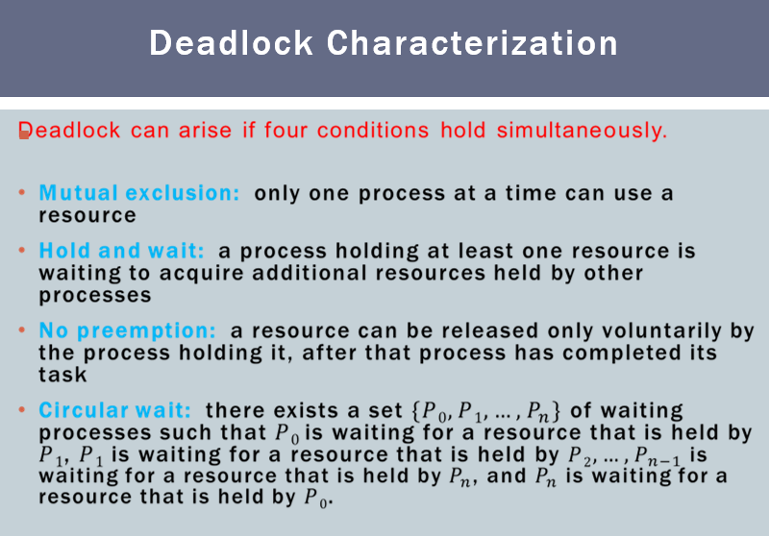
4.1 Resource-Allocation Graph (RAG)
A Resource-Allocation Graph is a directed graph used to describe the state of resource allocation in a system.
It shows:
- Which resources are allocated
- Which resources are requested
- Relationship between processes and resources
Components of RAG
1. Processes
- Represented by circles
- Denoted as: P1, P2, P3, …
- Each process may request or hold resources
2. Resource Types
- Represented by rectangles (boxes)
- Denoted as: R1, R2, R3, …
- Each resource type may have one or more instances
3. Resource Instances
- Shown as dots inside the rectangle
- Each dot represents one instance of the resource
Example:
- 4 dots inside Rj → 4 instances of resource Rj
Edges in RAG
1. Request Edge
- Direction: Process → Resource
- Written as: Pi → Rj
- Meaning: Process Pi is requesting an instance of resource Rj
2. Assignment Edge
- Direction: Resource → Process
- Written as: Rj → Pi
- Meaning: Resource Rj is allocated to process Pi
Important Understanding
- A process can:
  - Hold a resource (incoming edge)
  - Request another resource (outgoing edge)
- Deadlock occurs when processes form a cycle of waiting
Types of Resource Allocation Graph Situations
- Example of a Resource Allocation Graph (Normal Case)
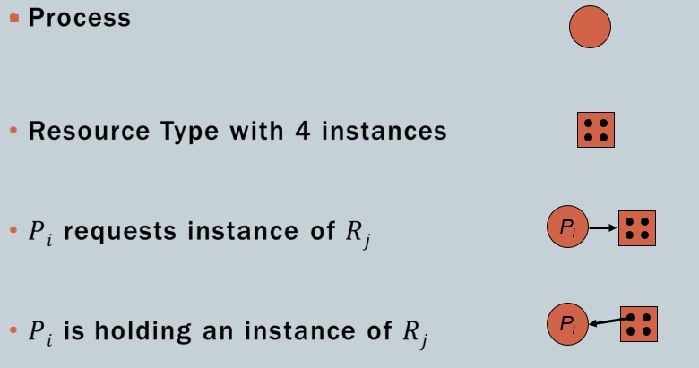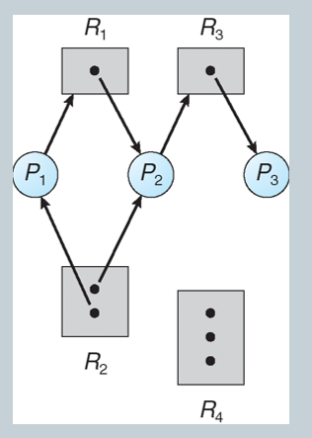
Description
- Processes: P1, P2, P3
- Resources: R1, R2, R3, R4
- Some resources have multiple instances (shown by multiple dots)
- The graph shows:
  - Some resources are allocated to processes
  - Some processes are requesting resources
Step-by-step Analysis
- Identify all processes and resources
- Observe allocation edges (who holds what)
- Observe request edges (who is waiting for what)
- Check for circular dependency
Observation
- There is no complete cycle involving all waiting processes
- Some processes can still proceed
Conclusion
- No deadlock exists
- System is in a safe and working state
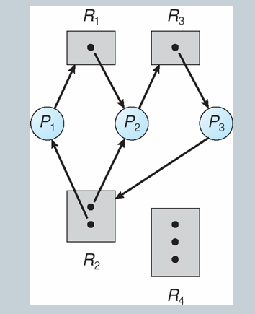
2. Resource Allocation Graph with Deadlock
Description
- Same type of components (processes and resources)
- But here, a cycle is clearly formed
Step-by-step Analysis
- Identify processes and resources
- Track allocation and request edges
- Find a cycle in the graph
Example cycle:
- P1 → R1 → P2 → R2 → P1
Observation
- Each process in the cycle is:
  - Holding one resource
  - Waiting for another resource
- No process in the cycle can proceed
Conclusion
- Deadlock exists
- All processes in the cycle are permanently blocked
3. Graph with a Cycle but No Deadlock
Description
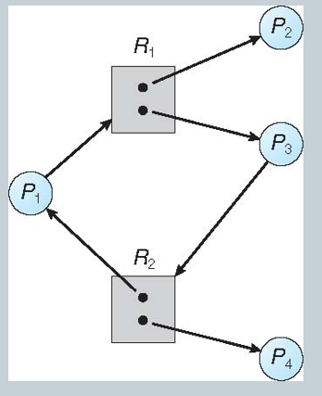
- The graph contains a cycle
- Resources have multiple instances
Step-by-step Analysis
- Identify processes and resources
- Observe that some resources have more than one instance
- Detect a cycle in the graph
- Check whether all processes are blocked
Observation
- Even though a cycle exists:
  - At least one process can still obtain a resource
  - That process can complete execution
  - It will release its resources
- This breaks the cycle
Conclusion
- No deadlock occurs
- System can still continue execution
4.2 Basic Facts
These rules summarize all graph cases:
Case 1: No Cycle
- If the graph has no cycle
→ Deadlock cannot occur
Case 2: Cycle Exists
Case 2a: Single Instance of Each Resource
- If each resource has only one instance
→ Cycle means deadlock will definitely occur
Case 2b: Multiple Instances of Resources
- If resources have multiple instances
→ Cycle means deadlock may or may not occur

5. Methods for Handling Deadlocks
Deadlocks can be handled in different ways depending on how the operating system is designed.
There is no single method, so systems choose one based on efficiency and complexity.
Main Approaches
There are four methods to handle deadlocks:
5.1 Deadlock Prevention
Idea
Ensure that the system never enters a deadlock state.
How it Works
- Restrict the way processes request resources
- Break at least one of the necessary conditions of deadlock
Result
- Deadlock is completely avoided
- But may lead to:
  - Low resource utilization
  - Possible starvation
5.2 Deadlock Avoidance
Idea
Allow resource requests only if the system remains in a safe state.
How it Works
- System checks before allocating resources
- It predicts whether granting the request will lead to deadlock
Result
- Deadlock is avoided intelligently
- Requires:
  - Extra information about processes
  - More computation
5.3 Deadlock Detection
Idea
Allow the system to enter a deadlock state, then detect it later.
How it Works
- No restrictions on resource allocation
- System periodically checks for deadlocks
Result
- Deadlocks are identified after they occur
- Requires detection algorithms
5.4 Recovery from Deadlock
Idea
Once a deadlock is detected, take action to recover from it.
Methods of Recovery
1. Process Termination
- Kill one or more processes
- Break the deadlock cycle
2. Resource Preemption
- Take resources from some processes
- Give them to others
Result
- Deadlock is resolved
- But may cause:
  - Data loss
  - Starvation
  - Restart overhead

6. Deadlock Prevention
Deadlock prevention ensures that the system never enters a deadlock state by restricting how resources are requested.
Key Idea
Deadlock occurs only if all four necessary conditions are present.
So, prevention works by eliminating at least one condition.
Methods of Deadlock Prevention
6.1 Mutual Exclusion
Concept
- Some resources are non-sharable (only one process can use them at a time)
- Example: Printer
Prevention Strategy
- Make resources sharable where possible
Important Point
- Mutual exclusion cannot be removed completely
- It is required for non-sharable resources
6.2 Hold and Wait
Concept
- A process is holding one resource while waiting for others
Prevention Strategy
Two approaches:
- Request all resources at once
  - Process must request and get all resources before execution
- Request only when holding none
  - Process can request resources only if it has no resources
Problems
- Low resource utilization
- Resources may remain unused
- Starvation possible
6.3 No Preemption
Concept
- Resources cannot be taken away from a process
Prevention Strategy
- If a process holding resources requests another resource and it is not available:
  - It must release all currently held resources
- These resources are given to other processes
Process Restart
- Process restarts only when:
  - It gets all old resources
  - And the new requested resource
Effect
- Prevents deadlock by avoiding waiting while holding resources
6.4 Circular Wait
Concept
- A set of processes waiting in a circular chain
Example:
- P1 waits for P2
- P2 waits for P3
- P3 waits for P1
Prevention Strategy
Resource Ordering (Enumeration)
- Assign a unique number to each resource type
- Example:
  - R1 = 1
  - R2 = 2
  - R3 = 3
- Processes must request resources in increasing order only
Rule
- A process cannot request a lower-numbered resource after holding a higher-numbered one
Why Enumeration Prevents Deadlock
- All processes follow the same order
- No process can go backward in order
- So:
  - Circular chain cannot form
  - Deadlock is prevented
Example
Resources:
- R1 < R2 < R3 < R4
Valid requests:
- P1: R2 → R4
- P2: R1 → R2
Invalid:
- Requesting R1 after holding R3

